7-1 Final Project

Elvina Medeiros

SNHU: CS-499-T1056 Computer Science Capstone 21EW1

Contents

Introduction 3

Current State 3

Post Change review 5

**References** 8

# Introduction

For the computer science capstone, I decided to create an ePortfolio for one of the classes I took recently. The CS-465: Full-stack development I - was one of the classes that were both challenging and interesting. In creating a full-stack application, I was responsible for designing the website, specifically Model View Controller (MVC) pattern and routing. MVC architecture separates the data (model), the display (view), and the application logic (controller). This separation aims to remove any tight coupling between the components, theoretically making code more maintainable and reusable. A bonus is that these components fit nicely into the rapid prototype development approach and allow concentrate on one aspect at a time.

I also had to use Handlebars (HBS) as my templating engine. Handlebars is a simple templating language. It uses a template and an input object to generate HTML or other text formats. Handlebars templates look like a regular text with embedded Handlebars expressions. The objective of the design portion of this project was to take the static HTML site and move it into JSON. The Full Stack Guide guided me through the necessary steps and provided deeper insights into these new tools, which allowed me to organize the app on the server, move routes and views inside a new folder, and start coding JavaScript for the MVC pattern.

After I implemented Handlebars (HBS) as my templating engine, I worked in the Database. The Full Stack Guide guided me through the necessary steps and provided deeper insights into these new tools, which allowed me to organize the app on the server, move routes and views inside a new folder, and start coding JavaScript for the MVC pattern. After I created 2 separate web pages that used handlebars, I decided to test the CRUD functionality and update one of the JSON (contains database) files with changes.

# Software Design, Engineering, and Data Structure: Current State

For class CS-465 we only had to use the handlebars feature for the travel page. As you can see from the screenshots below travel page is accessible from both HTML and Handlebars templates.

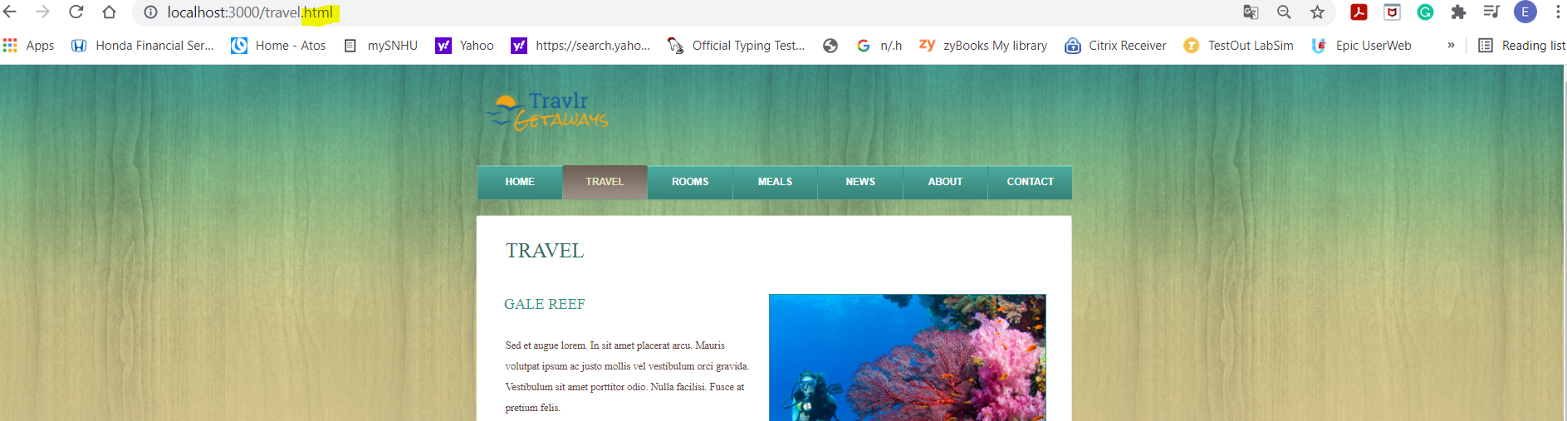

Screenshot 1 – Travel page HTML

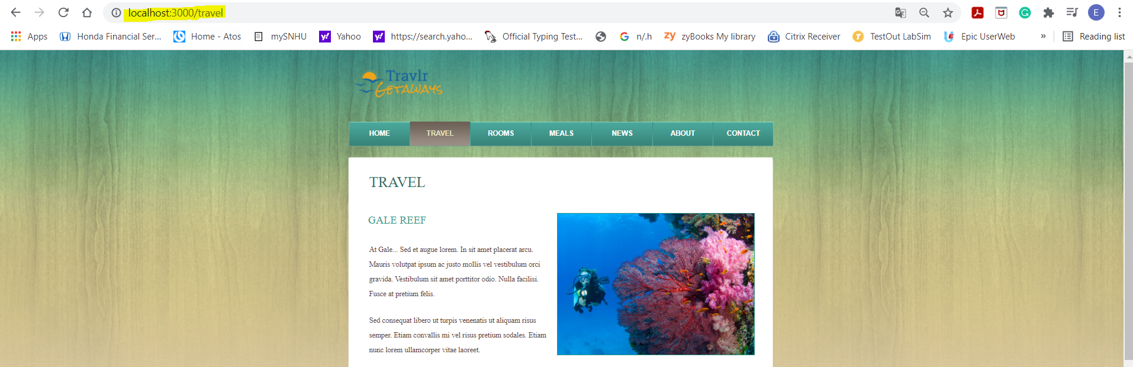

Screenshot 2 – Travel page handlebars

Handlebars feature is not accessible for other pages, such as rooms, meals, news, etc. Proposed changes include adding the handlebars feature to other pages.

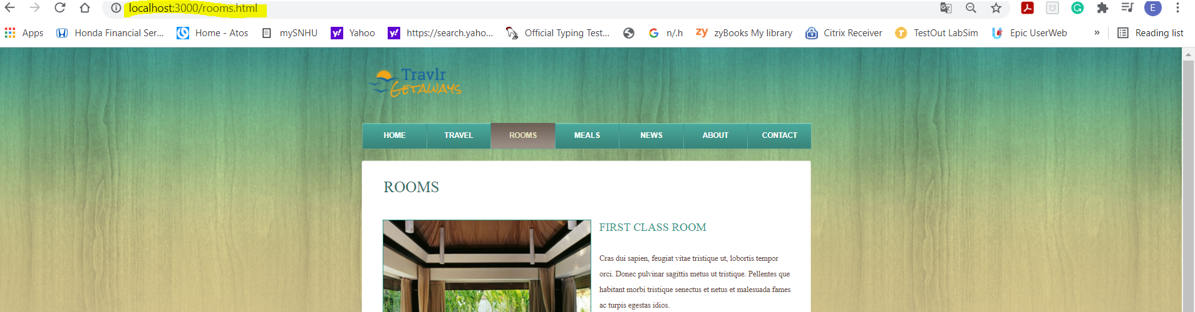

Screenshot 3 – Rooms page HTML

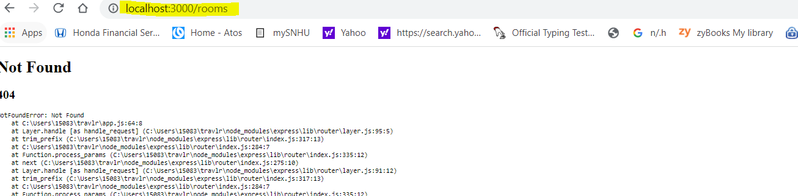

Screenshot 4 – Rooms page handlebars

Another way to simplify the code is to use another feature of handlebars, such as loops. We can notice in the rooms.hbs file that the code for the rooms is constantly repeating. The way to simplify it is to create a JSON file that contains information about all the rooms that are currently on-site and add each loop to the rooms.hbs file. This file should be in the data folder.

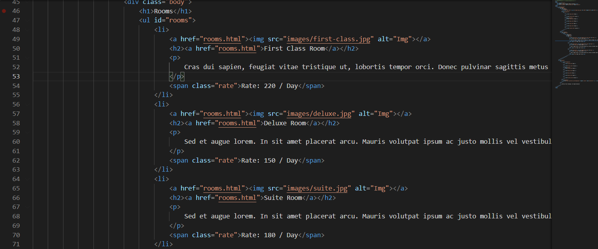

Screenshot 5 – Rooms file with all rooms listed in it.

# Software Design, Engineering, and Data Structure: Post Change review

To create a handlebar feature for the rooms page, I had to copy the rooms.html file from the public folder and paste it to the views folder. After that, I had to change the file format from HTML to hbs (handlebars). I had to enter the command header and footer into the new rooms.hbs file, so instead of storing header and footer information in rooms.hbs file itself we will store it in handlebars as we did for the travel page. After the file has been updated I had to also create a router and controller for a new room request. After the router and controller for page rooms have been created I had to update the app.js folder to include the new controller and router. The final result is allowing us to access page rooms from the hbs side. This new feature may not be noticeable to the end-user, but from the back-end development perspective, handlebars allowed us to decrease the code from 130 lines to 52, which will increase the speed of the website and will make the code easier for troubleshooting.

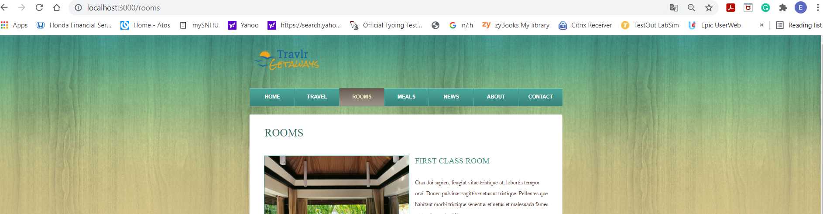

Screenshot 6 – Rooms page after changes with handlebars

After this was accomplished I created a room JSON file with information about all the rooms. And added the #each loop. Here is how it looks and the outcome.

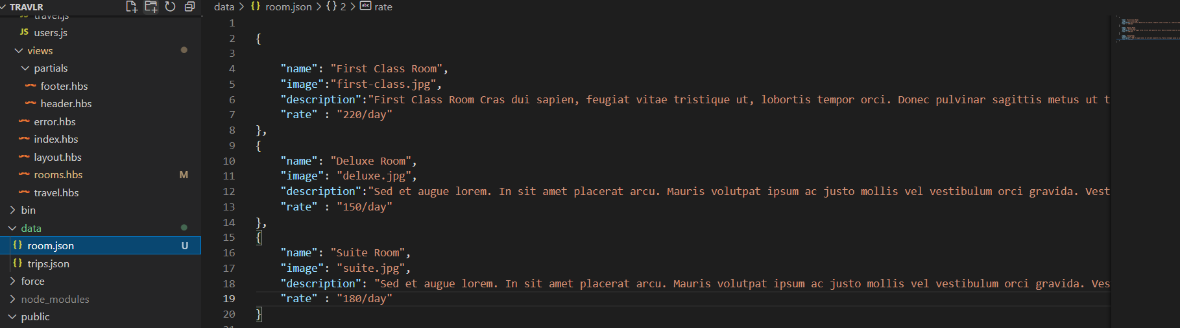

Screenshot 7 – Room.json file list all the info about the rooms we have

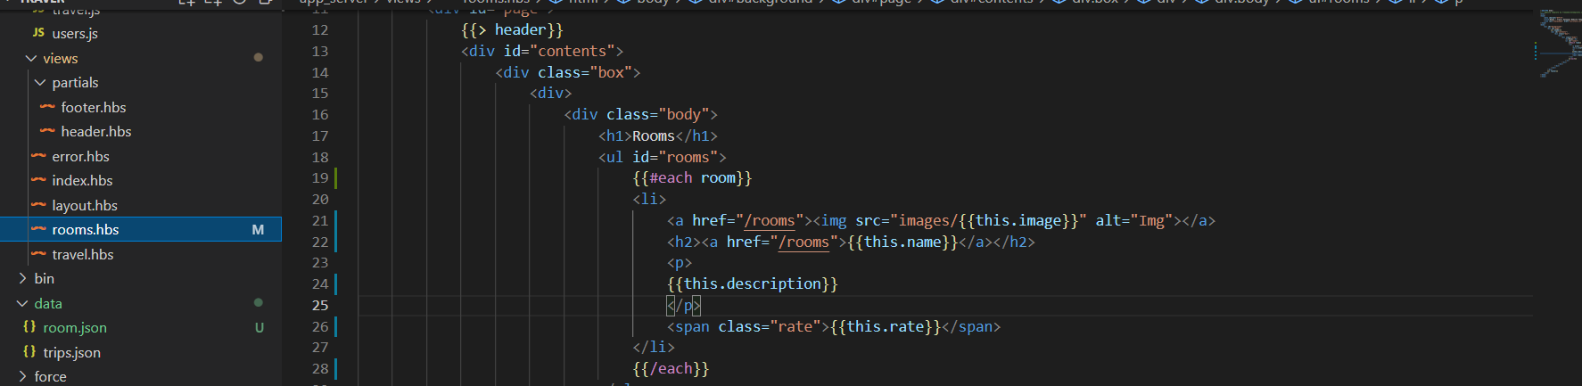

Screenshot 8 – rooms.hbs file with loop #each

In the summary, we can conclude that by using handlebars partials and loops we reduced the code from 113 to 38. Because of this change, it will be much easier to add/remove trips without dealing with the HTML portion of the code. And it also reduced the length of the code what will help with troubleshooting. Below is the website rooms page after changes.

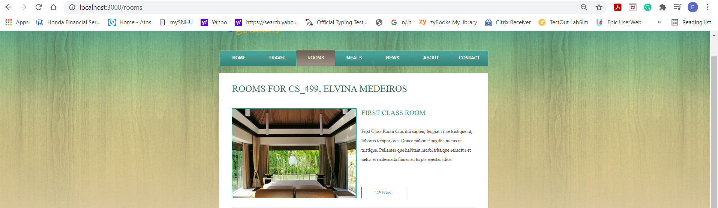

Screenshot 9 – Rooms page after changes

# Database: Current State

Previously I implemented Handlebars (HBS) as my templating engine, below I’ll post my work on the database side. After I created 2 separate web pages that used handlebars, I decided to test the CRUD functionality and update one of the JSON (contains database) files with changes.

Below you can find the HTML page room and page room that is using handlebars. As we already created a database for a page that is using handlebars, we will be updating that page.

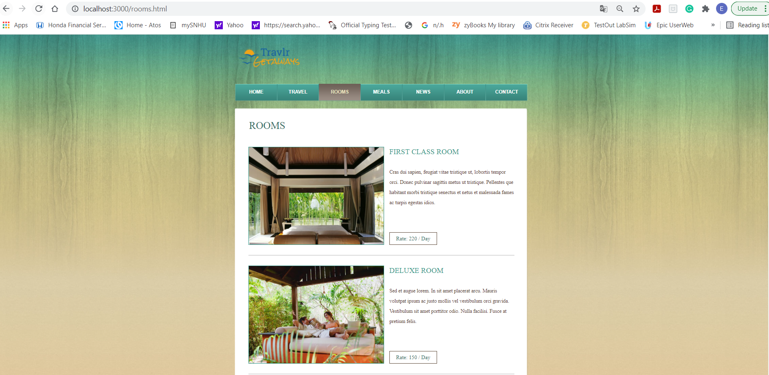

Screenshot 1 – HTML page room

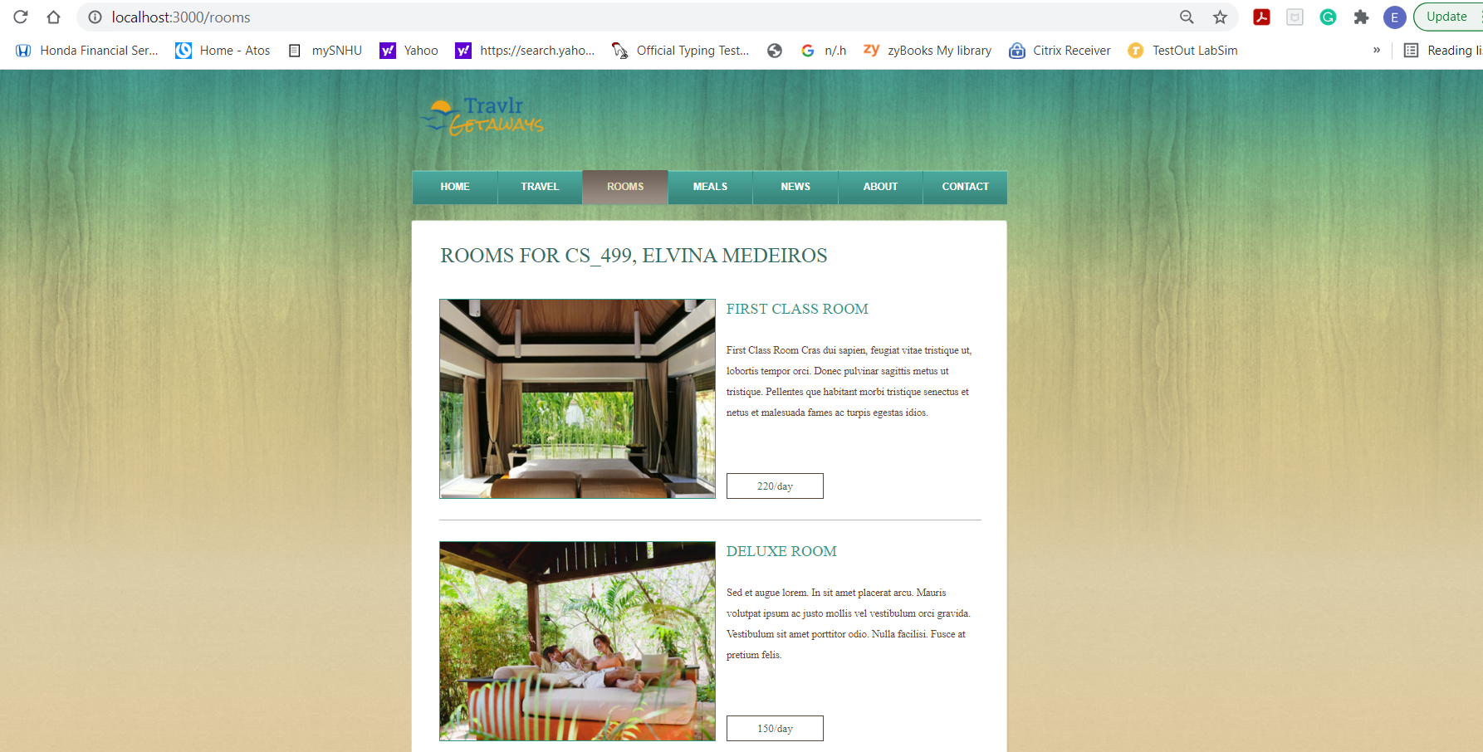

Screenshot 2 – Rooms page handlebars

The plan is to update the rooms page by updating the JSON file that contains all information about the rooms database. To fully use CRUD functionality we need to create 1 more room for this website, and we should update the fields in the database by adding field rating and deleting the description that was in Latin.

# Database: Post Change review

The first change that we had to do is to add field rating to the room.JSON file. Then we updated the description. The next part was to download new photos of the hotel’s rooms, resize them and change the source of the file in the code. After this, we had to update the HTML file code to recognize the new filed rating. We updated the HTML code by creating another loop for the rating field and by adding a symbol of a star to represent the rating. Please review the final look of the page rooms, using handlebars.

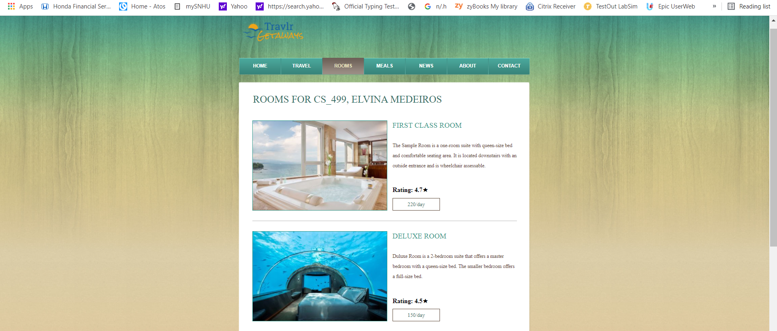

Screenshot 3 – Rooms page after the changes

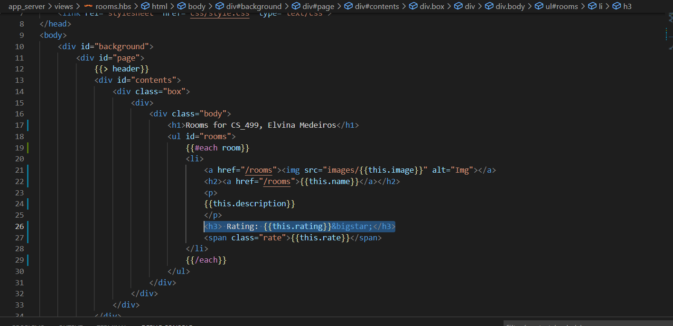

Screenshot 4 – Rooms.hbs file updates

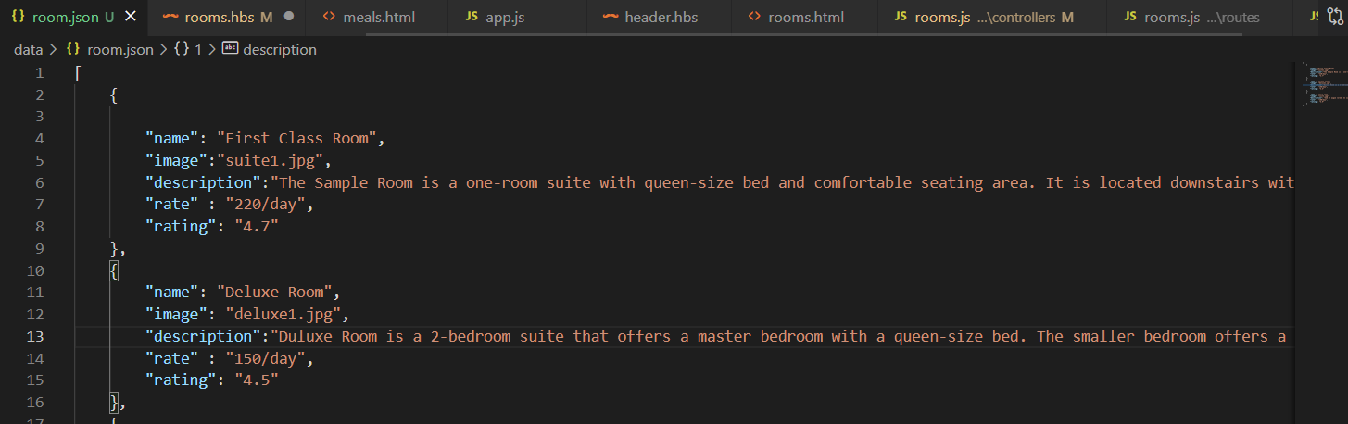

Screenshot 5 – room.json file with updates

In the summary, we have updated the database room.JSON file by updating images, descriptions and adding the new field rating. We also had to update the HTML file to recognize changes that were made in the database file. In the end, the changes didn’t take long and were very straightforward. This was possible because of the use of the functionality of handlebars.

References

Holmes, S. (2016) Getting MEAN with Mongo, Express, Angular, and Node. Retrieved September 20, 2021